ElectroRetailer

Project Code: **PRJ2232C**

Name: **Amit Narayan**

Roll No.: **20117**

Course: **BCA**

Batch: **3-2**

Class Roll No.: **29**

Session: **2020-2023**

**Index**

1. **Introduction --------------------------------------------------------------------------------- 2**
2. **Limitation of the Company -------------------------------------------------------------- 3**
3. **Purpose of our Software ----------------------------------------------------------------- 3**
4. **Modules Description ---------------------------------------------------------------------- 4**
5. **Data Description ---------------------------------------------------------------------------- 5**

**1. Introduction**

Here, I am talking about an electronic store whose name is **Spice Hot Spot.**This store was opened in 2015 by Harsh Raj. This store sells many electronic items like televisions, refrigerators, washing machines, mobiles, etc., with more than fifteen employees. In this store, they are managing their records on paper.

When they order some goods for sell. They have to maintain order-related data (like supplier details, product details, payment details, and purchase details) in different registers. Entering so many details took lots of time. It also causes data redundancy, meaning they must maintain the same data in registers. At the time of order receiving, they will have to check order details to verify goods quantities. After receiving the product, they have to maintain their product relate details (like stock details, product receiving details, and purchase invoices).

When a customer purchases some goods then they give a handwritten invoice. After that, they have to maintain their register (like customer details, product details, invoice details, transaction details, and stock details). Due to some product defect, the Customer wants to Exchange or return the product. For this reason, they have to rewrite a new exchange or return invoice with the same afford.

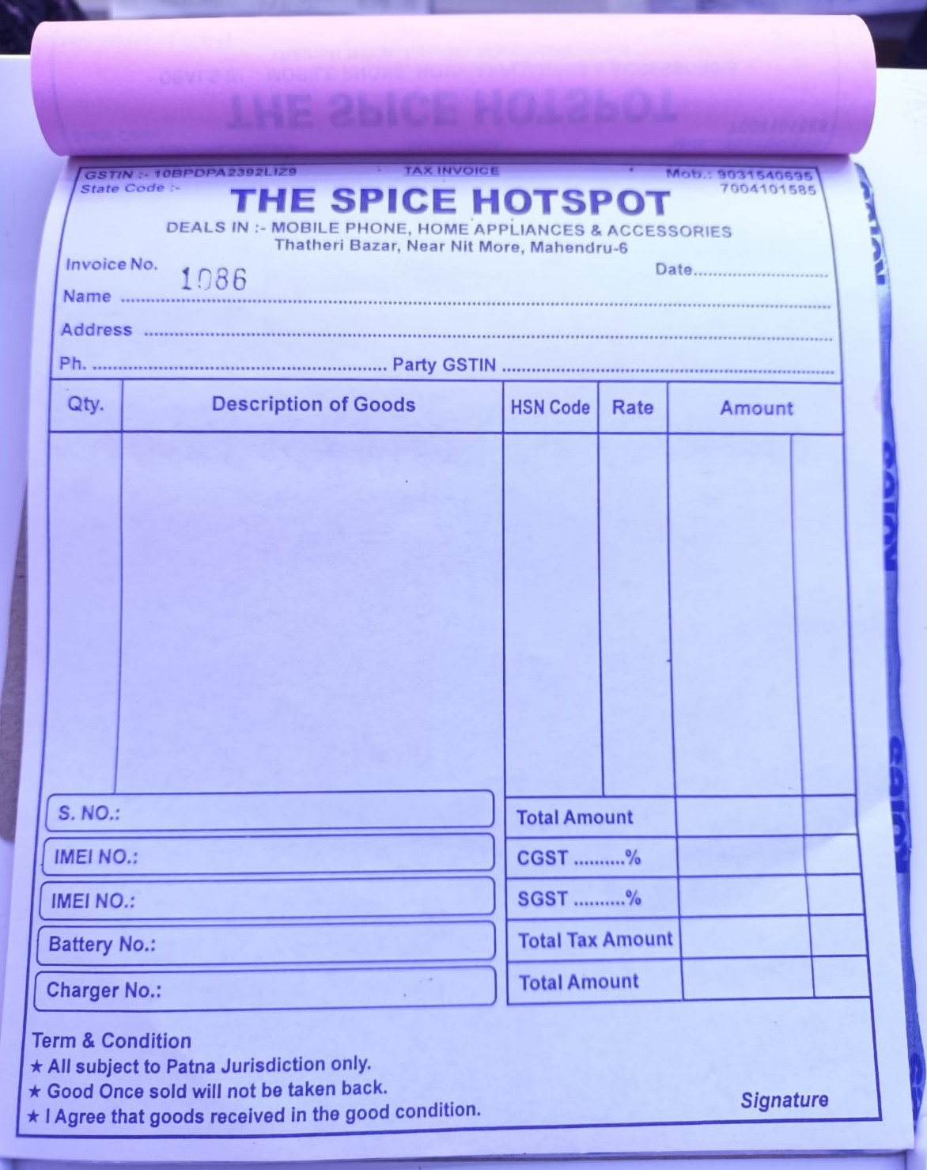

If we talk about employees, they maintain three types of records: employee details, wages, and attendance. Attendances are managed on daily basis. And their wages are managed on monthly basis. Employee details are managed at the time of joining.

Here we are talking about supplier-related details such as supplier details, purchase details (supplier-wise), purchase return details, and payment details.

They also maintain customer records such as their name, mobile, address, GST number (optional), purchase details, and product details.

Here I am talking about one of the most important details for every store or company: reports like sell reports, purchase reports, etc. a.) Sell-related reports in this record, they were maintaining their all sold product details on daily basis. b.) Purchase-related reports, in this record, maintain the purchase details, in two different records Supplier wise and date-wise. c.) A ledger is a type of report in which the sellers see all purchased or returned products and their payment-related details. Here they create a separate ledger for every supplier every month or yearly. d.) Profit-Loss is a type of report in which the seller sees the profits and losses on every bill. They also see their profit and loss within a certain duration of time. e.) last Balance-Sheet is a type of report in which the seller see their all direct (like purchase and sell) and indirect (like electricity bill, rent, POS, advertisement, etc.) debit and credit report.

Here we can see that they have to do hard work for maintaining records as well as for generating reports they take lots of time because they do all the work manually on registers.

**2. Limitations of the Company**

* When companies try to maintain their data within registers, they lose their data integrity.
* At purchase time, they were maintaining the same data type of records on different registers (like products, suppliers, payments, stocks, etc.).
* At sell time, they were calculating the amount of product manually. They also need to fill for exist customer data.
* At sale return time, they were filling the same bill data for returning goods.
* They were maintaining different registers for selling purposes, they were also repeating existing customer records.
* They were maintaining employee attendance on the register. This is time taking process for calculating their wages.
* For generating reports, it will take a lot of time to generate a single report and they were generating many types of reports.

**3. Purpose of our software**

* For security, we provide login credentials. With this software, you get three types of privileges - Superuser, Semi-super user, and user. Superusers have the right to create superusers, semi-superusers, users, and much more. Semi-superusers have the right to check all kinds of reports but they can create users. Users have limited privileges such as maintaining employee attendance, Billing, stocks, orders, etc.
* For purchase, you have to just select supplier then supplier details are automatically filled in the required place. After that, you will select an existing product or add a new product then enter a quantity and you may also able to update the price of an existing product. Here price of products will be calculated automatically with GST.
* For stocks, you will have to just open purchase the bill and click on delivered, it will automatically update stock.
* For sales, you have to enter customer details, product name, rate, and quantities. Their GST as well as the total amount will be automatically calculated.
* For Reports, You have to select which report you want to see. It will generate within seconds.

**4. Modules Description**

1. **Security Module** - It will insure that only authorized users are allowed to access their data.

* Sign-in function
* Privilege Checking function
* Database Connectivity function
* Sign-out function
* Switch user function

1. **Administrator Module**

* Create a new user
* Delete User
* Change Database Username and Password

1. **Purchase Module**

* Purchase function
* Return function
* Add Product function

1. **Sell Module**

* Purchase function
* Return function

1. **Employee Module**

* Registration function
* Attendance function
* Display Employees
* Salary Function

1. **Transaction Module** – this module manages all kinds of transaction
2. **Report Module**

* Sale Report function
* Purchase Report (Supplier wise or Date Wise)
* Ledger Report (Supplier Wise)
* Balance sheet Report (Monthly or Yearly basis)

1. **General Module**

* Stock function

**5. Data Description**

* **Login Credentials:**
* Username
* Password
* Privilege
* **Login details:**
* Login Date & Time
* Employee Details
* Log out Date & Time
* **Employees Details:**
* Name
* Mobile
* Email
* Aadhaar card
* Address
* Date of Joining
* Salary
* **Employee Attendance:**
* Month
* Present
* Leave
* EMPLOYEE DETAILS (foreign key)
* **Supplier Details:**
* Company Name
* Name
* Email
* Mobile No.
* GSTIN no.
* Address
* PAN
* Pin Code
* **HSN Code:**
* Code
* CGST/SGST
* **Product Details:**
  + Name
  + Company
  + Model no.
  + HSN Code
  + CP
  + Supplier Details
* **Customer Details:**
* Name
* Mobile
* Address
* Date
* **Transaction Details:**
  + Transaction id
  + DATE
  + PARTICULARS
  + Paid By: Card/CASH
  + CR/DR
* **Purchase Invoice:**
* Purchase Id
* Date & Time
* Supplier details
* Product details
* Product Rate
* Transaction Details
* **Sell Invoice:**
  + Sell id
  + DATE & TIME
  + Customer Details
  + Product Details
  + Serial No. / IMEI No.
  + Quantity
  + RatePerProduct
  + Bill by
  + Transaction Detail
* **General Expensi**